
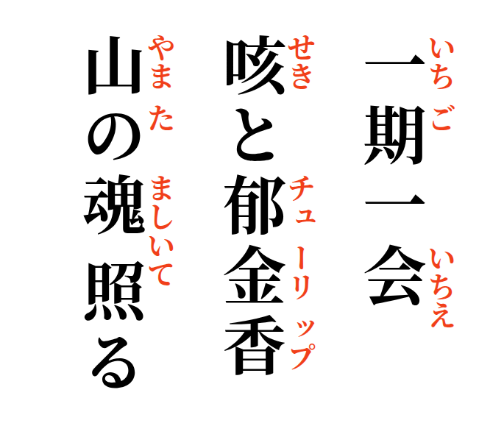
One time, one meeting—
a cough and a tulip;
the spirit of the mountain shines.

